Program2

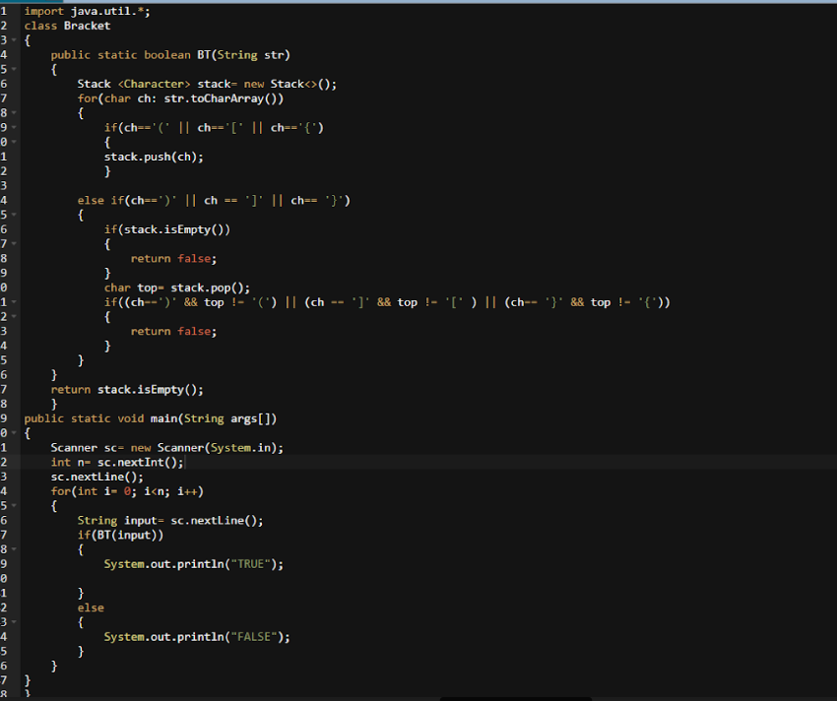

Output: ({[]})

True(Balanced Parenthesis)

({]

False(Unbalanced Parenthesis)